**SQL LAB-08**

**Database Backup using Cold Method:**

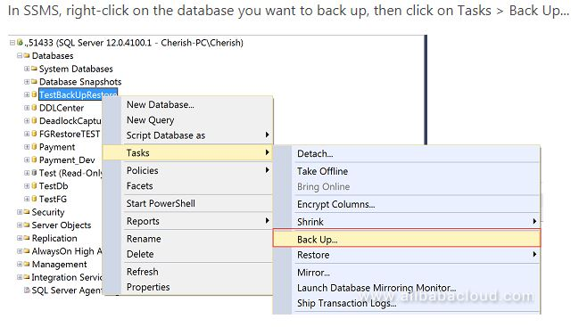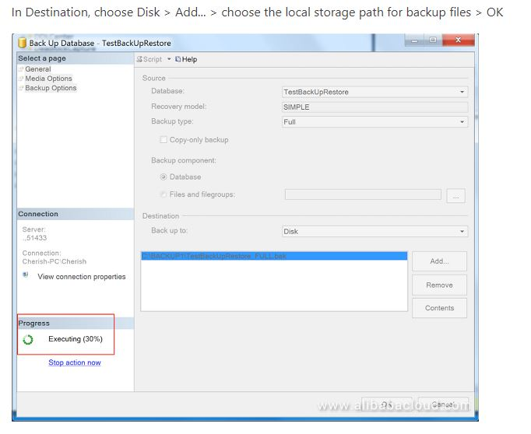

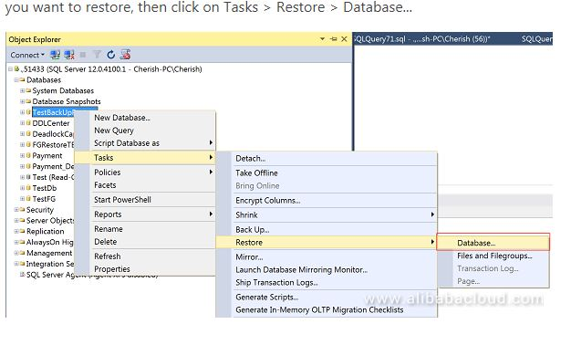

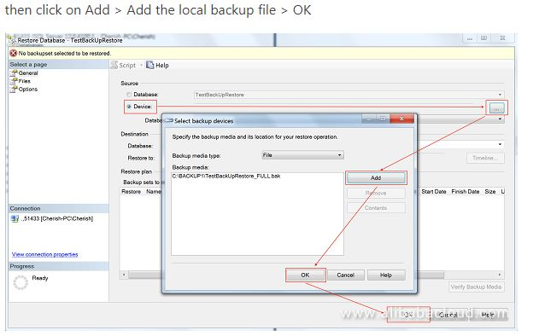

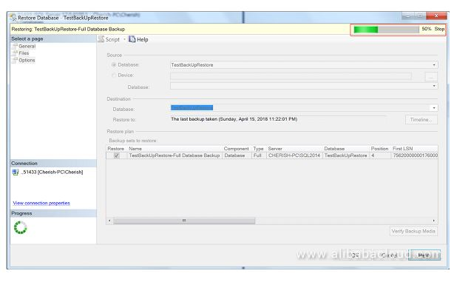

**Database Backup by Hot Method:**

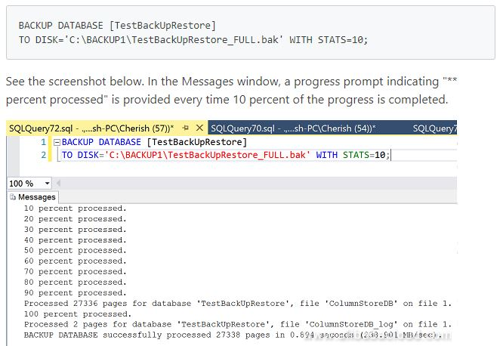

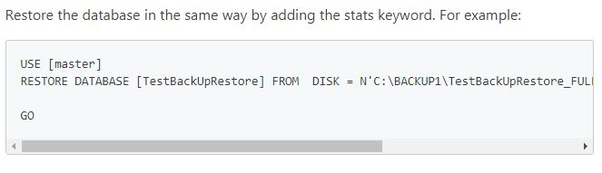

**SQL LAB-09**

**1- Relational Schema**

**Parent:**

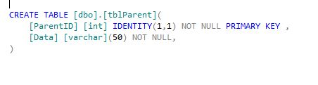

**Child:**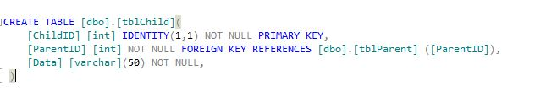

**Grand Child:**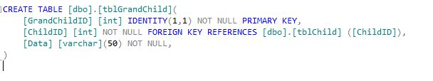

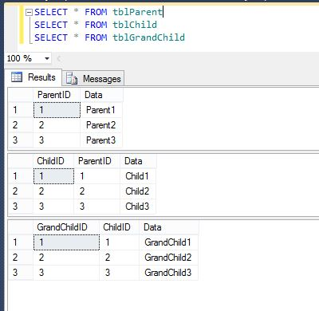

**Conflict on Update:**

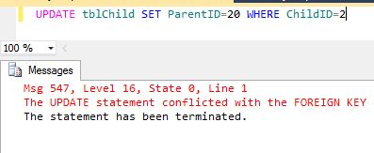

**Conflict on Delete:**

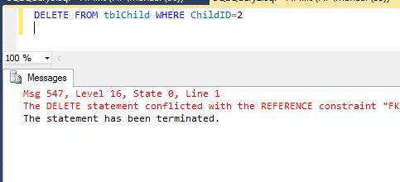

**Cascading On Update:**

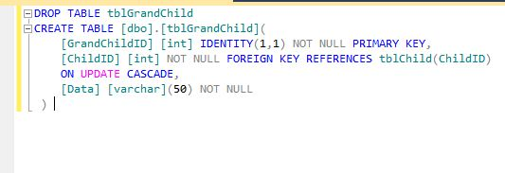

**Allow Delete after implementing Cascading:**

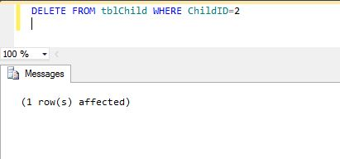

**Table Date Delete after Delete:**

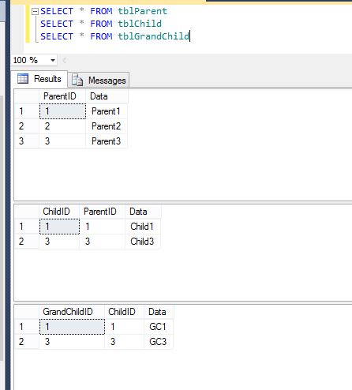

**SQL LAB-10**

**Select using Sub-Query:**

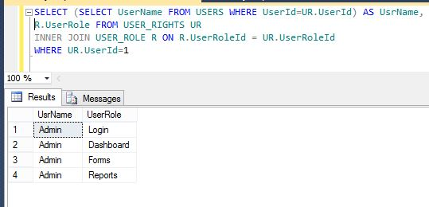

**Update using Sub-Query:**

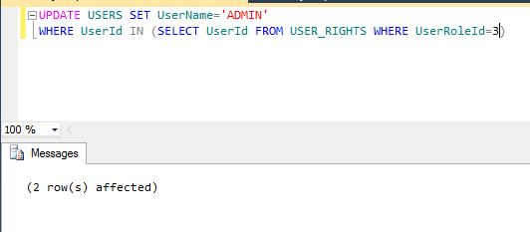

**Delete using Sub-Query:**

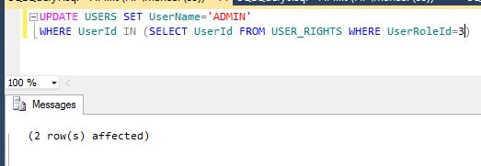

**SQL LAB-11**

**1- Lab Task: User Role Management**

**Create three tables**

|  |  |
| --- | --- |
| **C:\Users\manaal\Desktop\SQL\LAB9\TABLES.JPG** | **C:\Users\manaal\Desktop\SQL\LAB9\DATA.JPG** |

**Show User Rights through joining:**

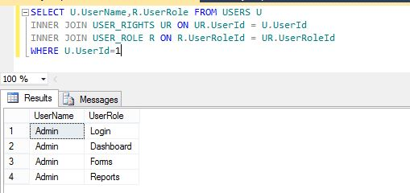

**SQL LAB-12**

**1- Create User Define Function to Split a given string**

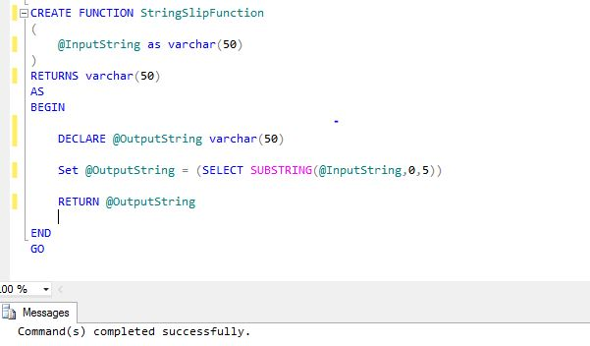**Result:**

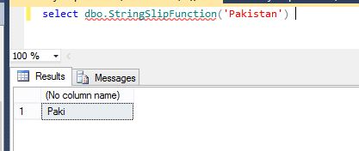

**2- SQL Aggregate Functions: COUNT, MAX**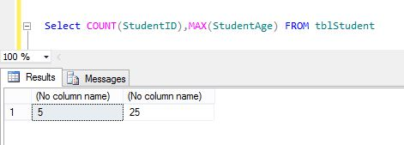

**3- SQL Date Functions: GETDATE, DATEADD, DATEDIFF, CURRENT_TIME_STAMP, DATEPART**

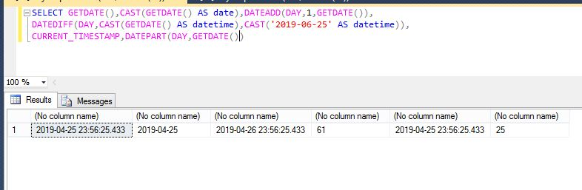

**4- SQL Math Functions: ROUND, CEILING, FLOOR**

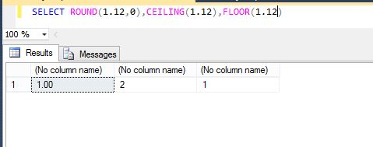

**5- SQL String Functions: SUBSTRING, LOWER, UPPER,**

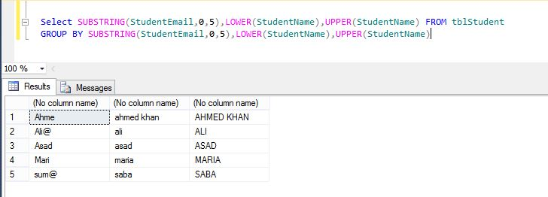

**RIGHT, LEFT, ISNULLL**

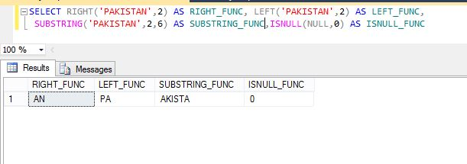

**LTRIM, RTRIM, REPLACE**

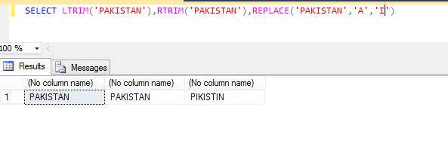

**REVERSE, FORMATE**

